**Feedback Management System Documentation**

1. **Login Page :**

We can login as a Admin and Student role. We can do rolebased login.

For login User Name is Email Id and Password is PRN number.

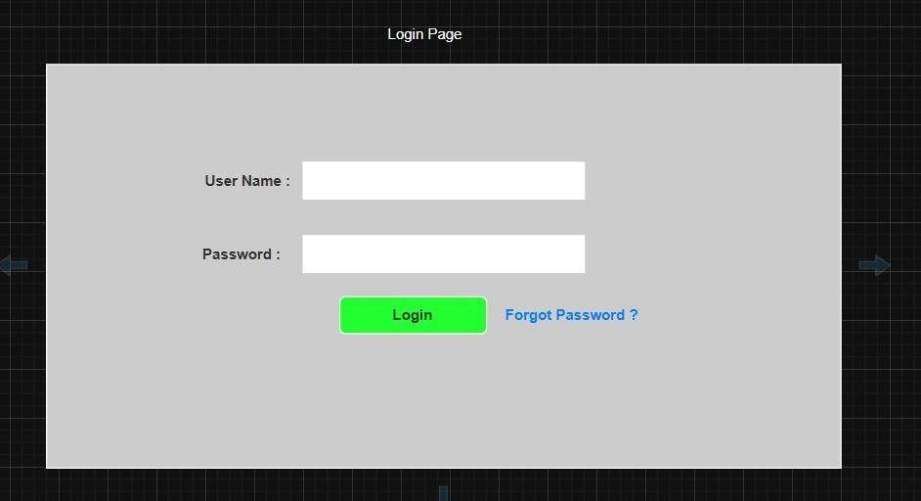

1. **Forgot Password :** 
   * + User set forgot password
     + User Name is Email Id

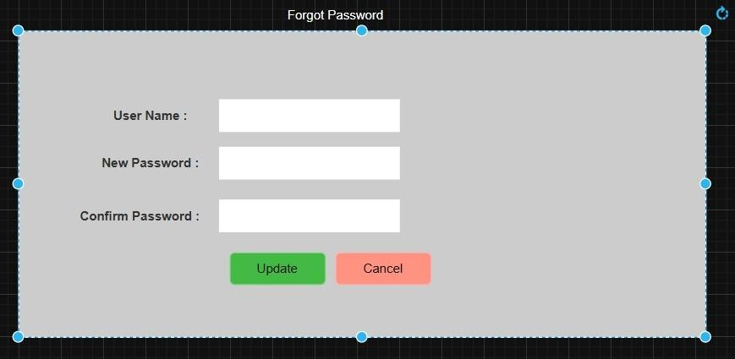

1. **Feedback Dashboard :** 
   * + All added feedback listed here.
     + Also you can filter Feedback as per your requirement
     + Admin can update and delete feedback

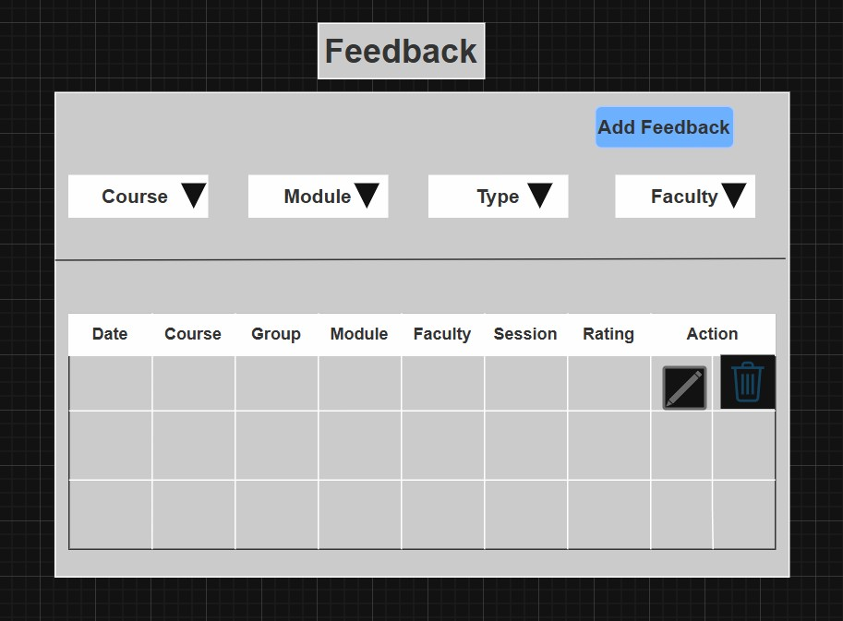

1. **Feedback Type Form:** 
   * + - Here we design a feedback type form for endmodule,mid module
       - We give title as whether type of form is end module or mid module according to that we give description
       - We select course for eg.k-dac-feb-25,k-dmc-feb-25 according to course we select respective module for eg.Dot Net,Java
       - After selecting course we select group as
       - a) Single - Theory
       - b) Multiple- Lab- if we select multiple according to that batch is allocated
       - we can select session yes or no and behaviour of feedback type form that is compulsory or optional
       - we have given add questions button to add questions and after clicking on add questions we can see add questions window after adding questions we can view questions in our form and submit the form. - Also can update and delete questions

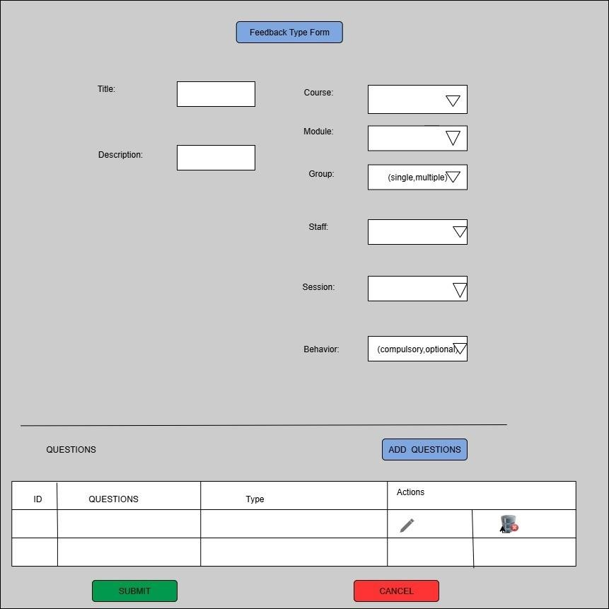

1. **Add Question :**

It is used for adding new questions into the system.

Question:-

Allows the user to type the question they want to add. Type:- Options:

* + DESCRIPTIVE (for long answer questions)
  + RADIO TYPE (for multiple choice questions)

Allows the user to select the format of the question.

---Add Button---

Submits the question and its type to be added to the system/database.

----Cancel Button-----

Cancels the current input and navigates the user back or clears the fields.

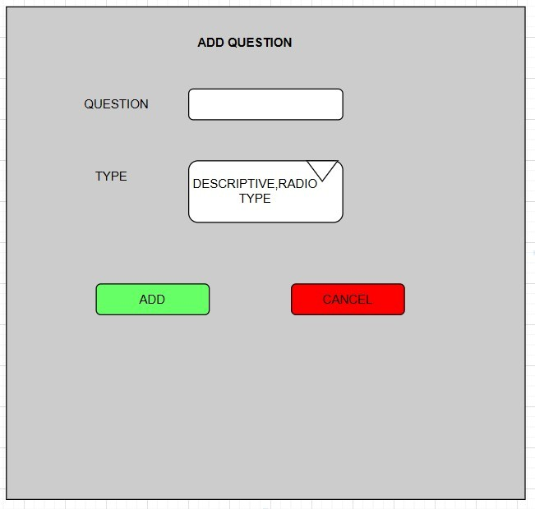

\***Use Case Diagram**

1.Use Case Diagram -ADMIN

2.Use Case Digram**-**STAFF

3 .use case diagram- Student

\***ER DIAGRAM**